How to use the Micro-USB on the front panel.

We can control the matrix and upgrade the matrix via this port.

Please find a Micro-USB cable, connect to the USB port on the front panel to your windows PC(Laptop/Desktop). It will install the driver aromatically when the matrix connected, please wait for a minute.

Take MX42 as an example,

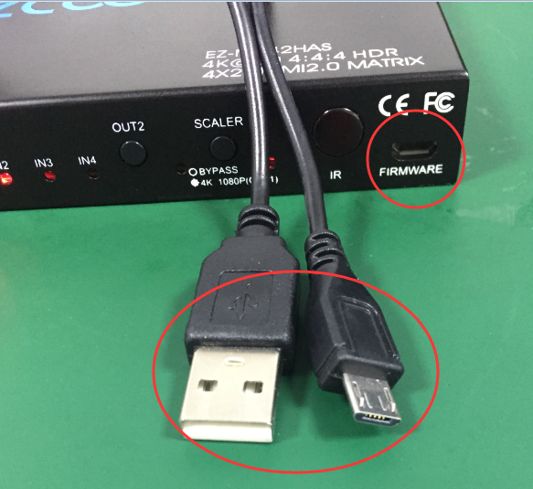

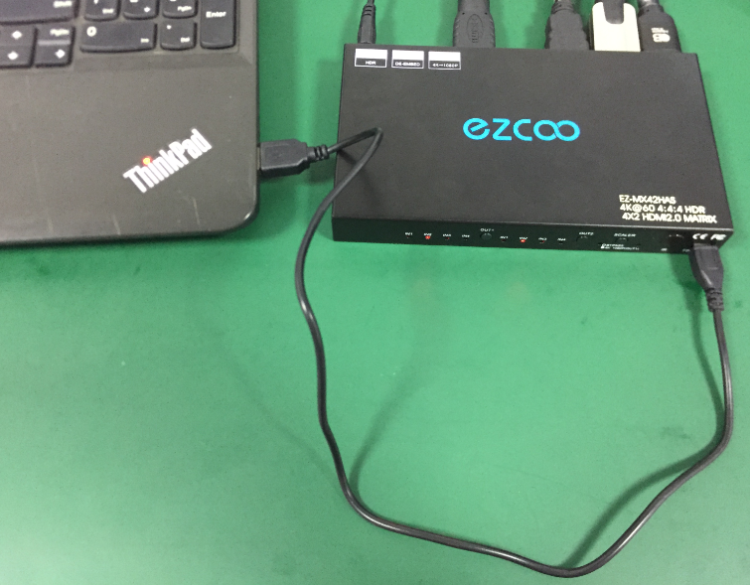

**Upgrade**

Baud Rate=57600bps, Data=8bit, Parity=None, Stop=1bit

Double click the UartAssist.exe. Set the correct parameters and click <Open>

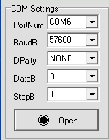

Send a command <ISP 32 1> +Enter, then click <Send> button.



After you sent this command, you will see <JUMP TO ISP MODE...>, and then click <Close>

All LEDs on the matrix will be off.

△ DO NOT remove any connection on the matrix at this time.

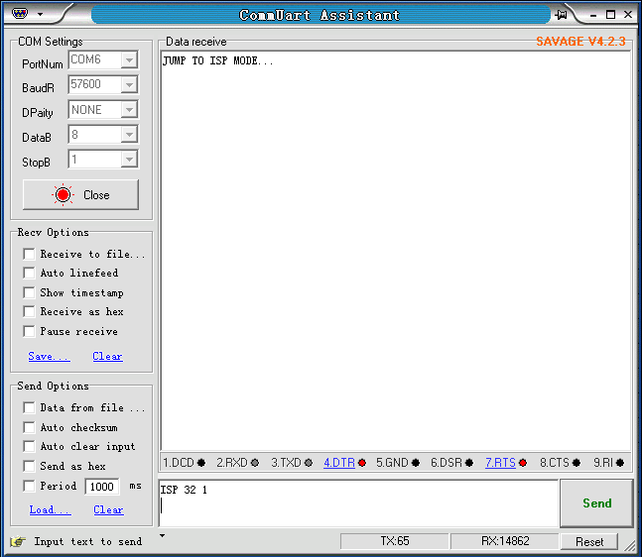

Then, double click the FlyMcu.exe, 

Following as below order:

1. Search the port
2. Select 57600 bps
3. Load the .hex file
4. Start to ISP (update)

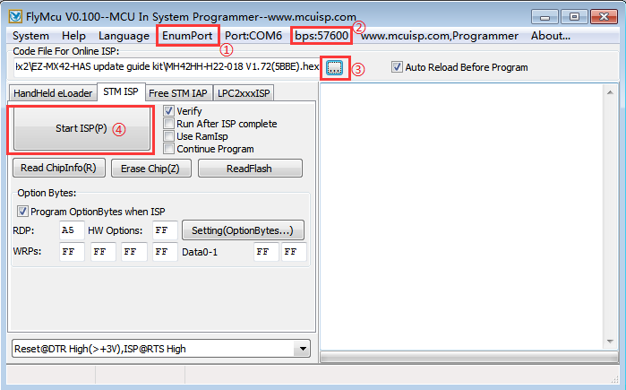

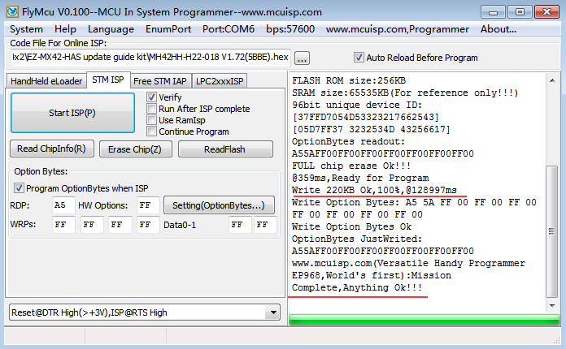

API command via USB port

Baud Rate=57600bps, Data=8bit, Parity=None, Stop=1bit

Double click the UartAssist.exe. Set the correct parameters and click <Open>

Please download the tool at

<https://www.easycoolav.com/art/tech-support-a0040.html>

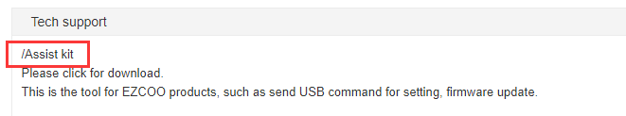



Send <H> + return to get command list.

<SET CAS EN>+ return-------strip out HDCP

SET IN 0 EDID X--------SET EDID

Ex: If you want to set Dolby vision and Atmos, just send <SET IN 0 EDID 31>+ return

Please follow below EDID list X=1---31

H1080P_2D_2CH_PCM,// 1

H1080P_2D_6CH, // 2

H1080P_2D_8CH,//3

H1080P_3D_2CH_PCM, //4

H1080P_3D_6CH, // 5

H1080P_3D_8CH, //6

H4K30Hz_3D_2CH_PCM, //7

H4K30Hz_3D_6CH , //8

H4K30Hz_3D_8CH , //9

H4K60Hz_Y420_3D_2CH_PCM, // 10

H4K60Hz_Y420_3D_6CH, //11

H4K60Hz_Y420_3D_8CH, // 12

H4K60HZ_3D_2CH, //13

H4K60HZ_3D_6CH,// 14

H4K60HZ_3D_8CH,//15

H1080P_2D_2CH_PCM_HDR, // 16

H1080P_2D_6CH_HDR, // 17

H1080P_2D_8CH_HDR, //18

H1080P_3D_2CH_PCM_HDR, //19

H1080P_3D_6CH_HDR ,//20

H1080P_3D_8CH_HDR ,//21

H4K30Hz_3D_2CH_PCM_HDR, //22

H4K30Hz_3D_6CH_HDR, //23

H4K30Hz_3D_8CH_HDR, //24

H4K60Hz_Y420_3D_2CH_PCM_HDR //25

H4K60Hz_Y420_3D_6CH_HDR, //26

H4K60Hz_Y420_3D_8CH_HDR,//27

H4K60HZ_3D_2CH_HDR,//28

H4K60HZ_3D_6CH_HDR,//29

H4K60HZ_3D_8CH_HDR,//30

H4K60_Dolby_Vision_Atmos, //31